**Sample Output**

**Main Menu**

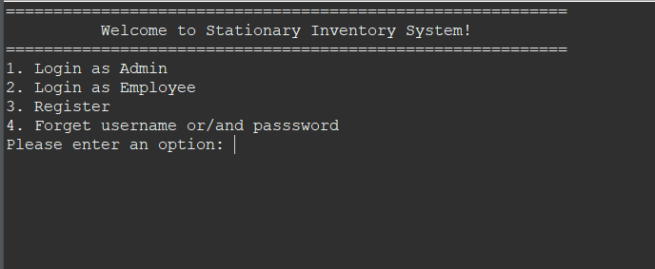

Figure 1: Stationary Inventory System’s Main Menu

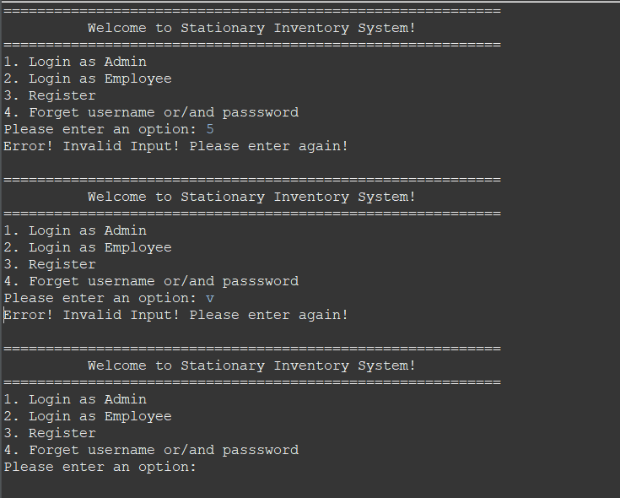

Figure 2: Display error message when invalid option entered and prompt employee to re-enter.

**User**

Figure 3: Users input option “1” to login as admin. Display login successfully message when admin successfully login to the system.

Figure 4: Users input option “2” to login as employee. Display login successfully message when employee successfully login to the system.

Figure 5: Display error message when invalid option entered and prompt users to re-enter. Three login attempts are given to the users. If user failed three login attempts, it would exit the system.



Figure 6: If the users login successfully into the system, it will display restock alert to notify the users on the product that are low on stock.

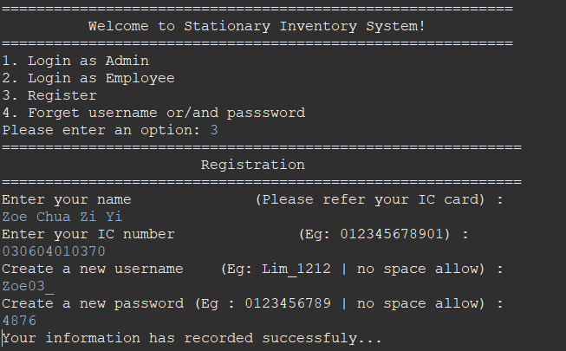

Figure 7: Users input “3” to register new employee profile. Display successfully message when new employee successfully registered to the system.

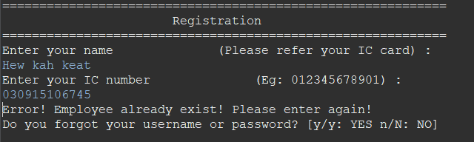

Figure 8: If the employee already existed, the system would display error messages. If the user has forgotten their username or password, the system provides options for account recovery.

Figure 9: Display error message for when invalid input occurs.

**If “Yes”**

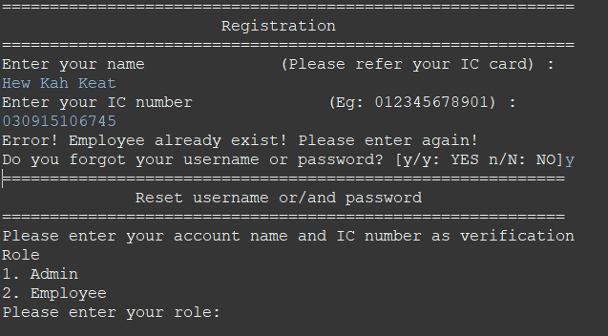

Figure 10: If the employee inserts “yes”, it will allow employee to reset their username or/and password.

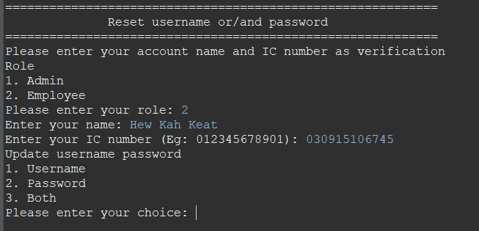

Figure 11: Employees select option “2” to reset, the system will request them to insert their full name and IC number. Then, the system will provide options for the employee to update either their username or password or both.

**If “No”**

Figure 12: For forgot username and password, if user key in no, they should re-enter their IC number to create their new account.

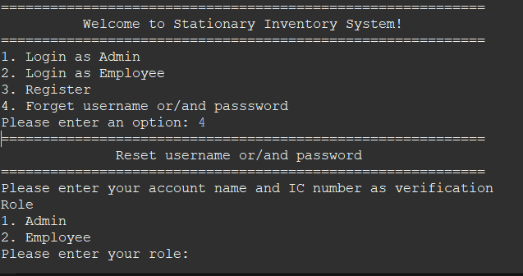

Figure 13: User input “4” to reset their username or password if they forgotten their username or password.

Figure 14: Display error message when invalid option entered and prompt employee to re-enter. Three attempts are given to the users. If user failed three attempts, it would exit the system.

Figure 15: Display error message for when invalid input occurs. Display error message when invalid option entered and prompt employee to re-enter.

Figure 16: The admin selects “1” to reset their username or password. The system will request the admin to insert their name and IC number.

Figure 17: The employee selects “2” to reset their username or password. The system will request the employee to insert their name and IC number.

**Admin**

Figure 18: Admin main menu will be display when users login as admin.

Figure 19: Display error message when invalid option entered and prompt users to re-enter.

Figure 20: Display error message when invalid input entered and prompt users to re-enter.

Figure 21: Admin will be logged out and system will be closed when admin entered option “5”.

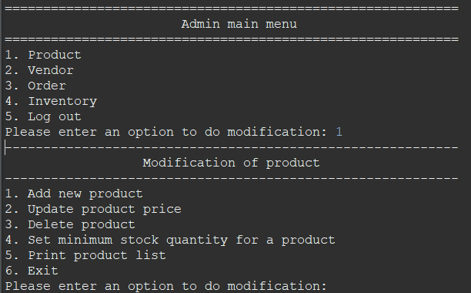

Figure 22: Admin can do modification on product when select option “1”.

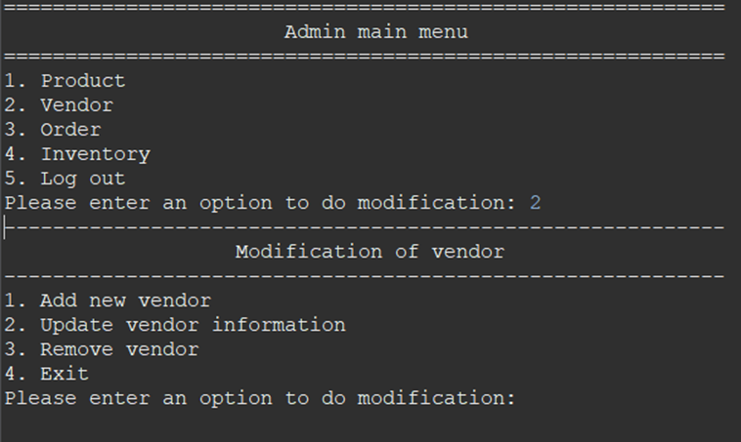

Figure 23: Admin can do modification on vendor when select option “2”.

Figure 24: Admin can do modification on order when select option “3”.

Figure 25: Admin can do modification on inventory when select option “4”.

**Product**

Figure 26: Display error message when invalid option entered and prompt user to re-enter.

Figure 27: Display error message when invalid input entered and prompt user to re-enter.

Figure 28: Admin entered option “1” to add new product, admin firstly need to enter the product name.

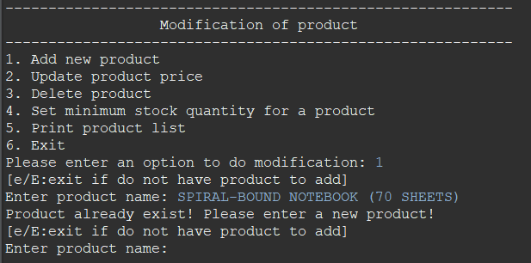

Figure 29: System checks the existence of the product name entered. If the product name entered is exist, system display error message and prompt user to re-enter the new product name.

Figure 30: Admin required to enter the product details and system will check the validity of product details entered. If invalid, system will prompt user to re-enter. If all the product details are valid, system display added successfully message and return to modification page.

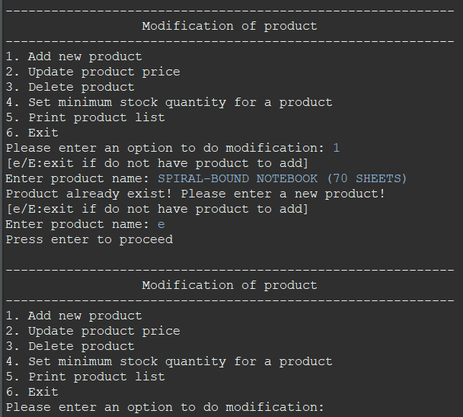

Figure 31: Admin will return to the modification page if entered “e” or “E”

Figure 32: Admin enter option “2” to update product price. Admin enter search option and system will check the validity of the option entered

Figure 33: Admin enter the search information and system will check the validity, if the information entered not found, system display error message and return to modification page.

Figure 34: Admin enter new price of the product and system will check the validity, if the price entered is invalid, system display error message and return to search option.

Figure 35: Admin enter valid new price of the product, system display update successful message and user will be return to modification page.

Figure 36: Admin enter option 3 to delete product. After user entered valid search option and valid search information of the product, system display delete successful message and user will be return to modification page.

Figure 37: Admin enter option “4” to set product minimum stock quantity, system check the validity of the product minimum stock quantity entered. If invalid, system display error message and return to search option.

Figure 38: After admin entered valid search option and valid search information of the product, system display delete successful message and user will be return to modification page.

Figure 39: Admin enter option “5” to print product list, system will display product list.

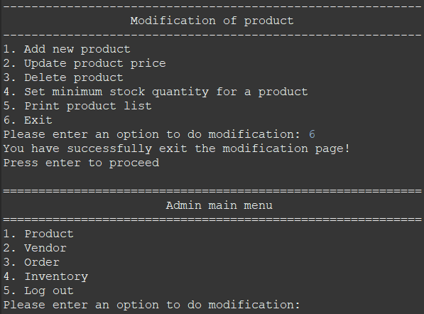

Figure 40: Admin enter option “6” to exit modification page, system will exit to admin main menu.

**Employee**

Figure 41: Employee main menu will be display when user login as employee.

Figure 42: Display error message when invalid option entered and prompt employee to re-enter.

Figure 43: Employee will be logout and system will be closed when employee entered option “3”

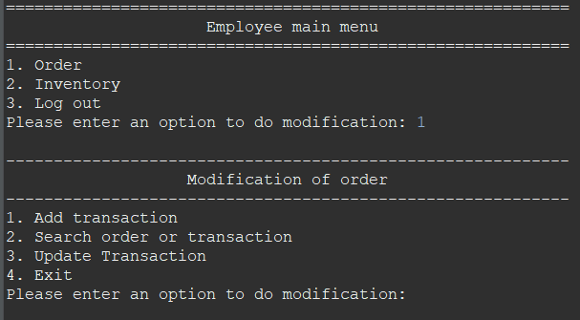

Figure 44: Employee can do modification on order when entered option “1”.

Figure 45: Employees can do modification on inventory when entered option “2”.

**Order**

Figure 46: Display error message when invalid option entered and prompt users to re-enter.

Figure 47: Employee entered option “1” to add transaction, employee firstly need to enter the order id.

Figure 48: Employee will return to the modification page if entered “e” or “E”

Figure 49: Employee required to enter the order details and system will check the validity of order details entered. The system will check whether the product exist in the product file. The system will display the available stock. If the stock-out quantity is more than the available stock, it will display product is out of stock. The system also valid the format of the date entered. If invalid input, the system will prompt user to re-enter. If all the order details are valid, system display added successfully message and query whether the employee wants to add more transactions.

Figure 50: If employees entered “y” or “Y”, the system would allow employees to continue adding new transactions until they enter “n” to stop.

Figure 51: If users entered “n” or “N”, the system would return to modification page.

Figure 52: Users entered option “2” to search transaction, the system will display two search options.

Figure 53: Display error message when invalid option entered and prompt users to re-enter.

Figure 54: Users entered option “1” to search order, they firstly need to enter the order id.

Figure 55: Display error message when invalid option entered and prompt users to re-enter.

Figure 56: Users search an order using the order ID. If the order ID existed in the order file, it will display the order record. The system will compute line total of each transaction details. The system will compute the total price of the order.

Figure 57: Users entered option “2” to search transaction, they firstly need to enter the order id.

Figure 58: Display error message when invalid option entered and prompt users to re-enter.

Figure 59: Users search a transaction in an order using the order ID. If the order ID existed in the order file, it will display the transaction record which includes the available product in that transaction. The system will check the validity of product name entered and display the transaction details. The system will compute line total of the transaction details.

Figure 60: Users entered option “3” to update transaction, they firstly need to search for the order to update using order ID.

Figure 61: Display error message when invalid option entered and prompt users to re-enter.

Figure 62: If the order ID existed in the order file, it will display the available product in that order. The system will system will check the validity of product name entered, display error message when invalid option entered and prompt users to re-enter. The system will display the update options for the users.

Figure 63: Display error message when invalid option entered and prompt users to re-enter.

Figure 64: Users entered option “1” to update the stock-out quantity of the selected product. The system will display the current stock-out quantity and the available stock. The system will display a message when the new stock-out quantity had been successfully updated.

Figure 65: If the entered new stock-out quantity is more than the available stock, it will display error message and prompt the users to re-enter.

Figure 66: Display error message when invalid option entered and prompt users to re-enter.

Figure 67: Users entered option “2” to update the payment method of the selected product. The system will display the available payment method. The system will display a message when the new payment method had been successfully updated.

Figure 68: Display error message when invalid option entered and prompt users to re-enter.

Figure 69: Users entered option “3” to return to modification of order.

**Inventory**

Figure 70: Display error message when invalid option entered and prompt employee to re-enter.

Figure 71: Employee entered option “1” to add inventory, employee firstly need to enter the product id.

Figure 72: Employee will return to the modification page if entered “e” or “E”

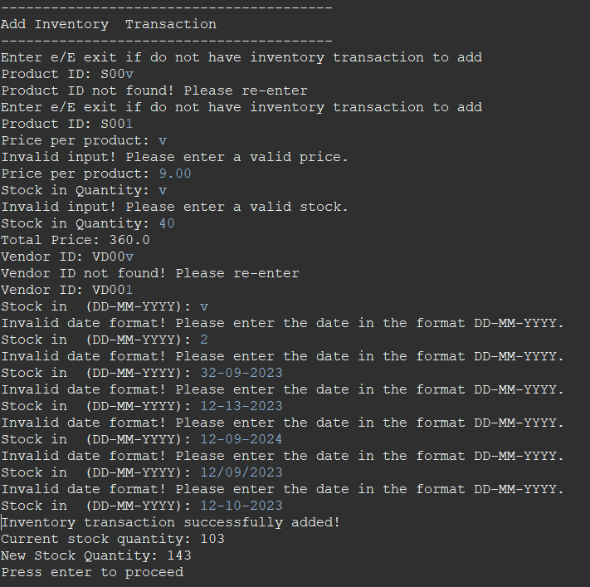

Figure 73: Employee required to enter the inventory transaction details and system will check the validity of inventory transaction details entered. If invalid, system will prompt user to re-enter. The system also valid the format of the date entered. If all the inventory transaction details are valid, system display added successfully message and return to modification page.

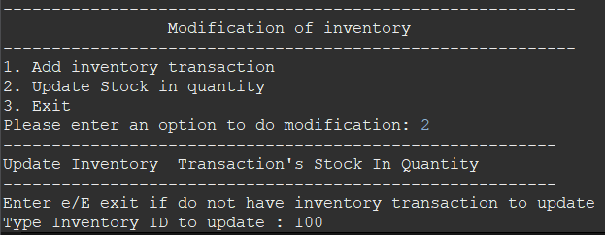

Figure 74: Users entered option “2” to update inventory transaction’s stock-in quantity.

Figure 75: Display error message when invalid option entered and prompt users to re-enter.

Figure 76: If the inventory ID existed in the inventory file, it will display the inventory transaction details. The system will prompt users to enter the new stock-in quantity. The system will display a message if the inventory transaction’s stock-in quantity had been successfully updated.

Figure 77: Display error message when invalid option entered and prompt users to re-enter.

Figure 78: Employees entered option “3” to return to modification of inventory.

**Vendor**

Figure 79: Display error message when invalid option entered and prompt admin to re-enter.

Figure 80: Admin entered option “4” to return to admin main menu.

Figure 81: Admin entered option “1” to add new vendor

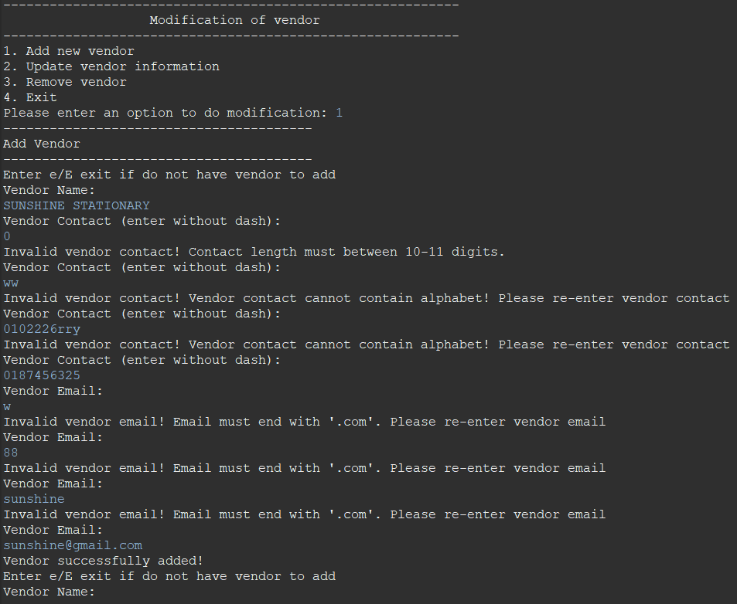

Figure 82: Admin entered vendor details including name, contact and email, system check the validity of details entered. System will display error message and prompt admin to re-enter if details entered is invalid.

Figure 83: System display added successful message when all the details entered are valid.

Figure 84: Admin will return to the modification page if entered “e” or “E.

Figure 85: Admin entered option “2” to update vendor information, admin firstly need to enter vendor id.

Figure 86: Display error message when invalid option entered and prompt admin to re-enter.

Figure 87: If the vendor ID existed in the vendor file, system will display the vendor information. The system will display the update options for the admin.

Figure 88: Display error message when invalid option entered and prompt users to re-enter.

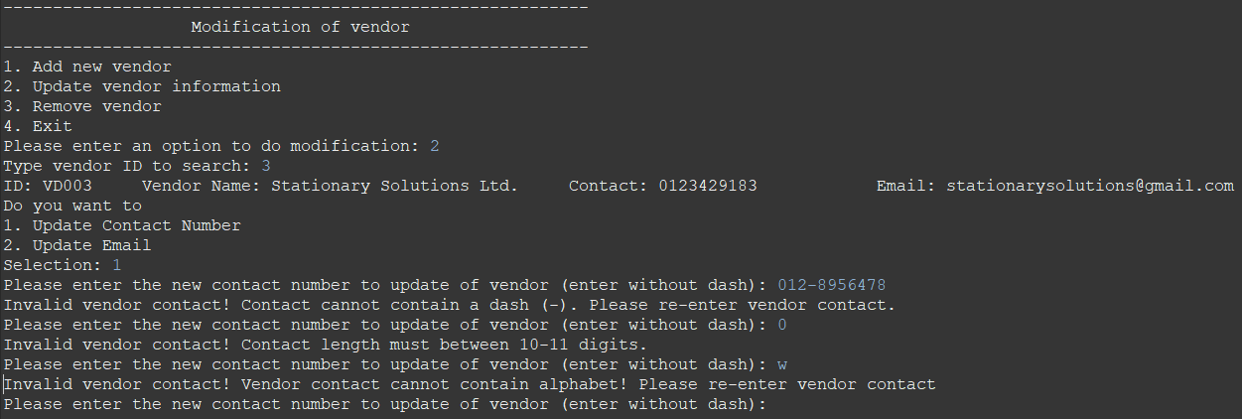

Figure 89: System will check the validity of the information admin entered based on the selection. If the information entered is invalid, system display error message and prompt user to re-enter.

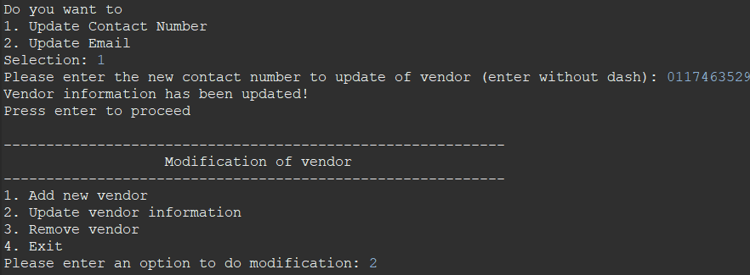

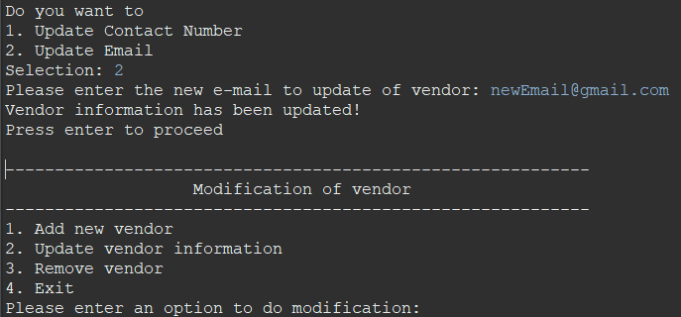

Figure 90: System display update successful message when the information to update entered are valid. System will then return to vendor modification page.

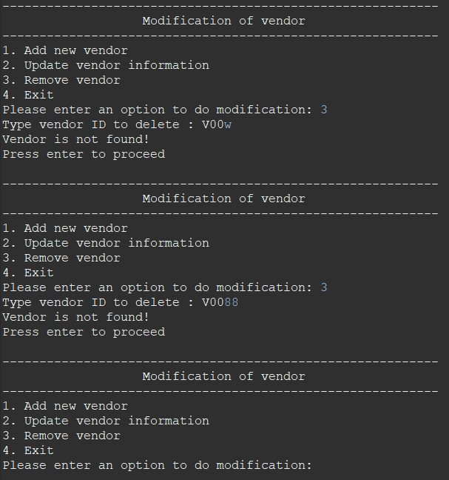

Figure 91: Admin entered option “3” to remove vendor. System checks the validity of vendor ID entered. If invalid, system display error message and return to vendor modification page.

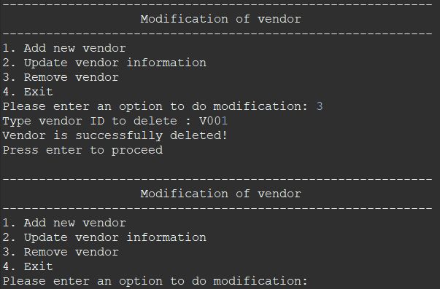

Figure 92: When admin entered valid ID, system display remove successful message and return to vendor modification

Figure 93: Admin enter option “4” to exit from vendor modification page, system will return to vendor main menu page.